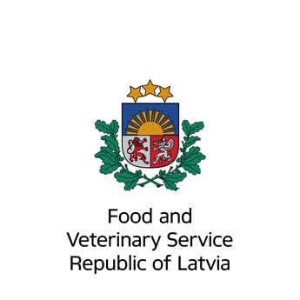 | NOTIFICATION OF MARKETING STATUS OF VETERINARY MEDICINal product  The Marketing Authorization Holder is required to notify the Food and Veterinary Service of Latvia when veterinary medicinal product is placed on the market or withdrawn temporarily or completely from the market, pursuant to Article 62. of the Cabinet of Ministers Regulation No. 600. of July 18, 2006 „Marketing Authorisation of Veterinary Medicinal Products”

PRODUCT DETAILS
Name of the veterinary medicinal product:

Pharmaceutical strength and form:

Marketing Authorisation number:

Marketing Authorisation holder:

PACK DETAILS
Product ID number | Pack size | Container

1. PLACING ON THE MARKET
Initial placing on the market (date):
Date of resumption of distribution (following interruption):
Official importer(s) in Latvia:
2. Interruption to distribution:
Date of last delivery to wholesaler:
Expected resumption of distribution on (year/month):
reasons for non-marketinG
Please tick the relevant box and provide brief details
Commercial
Quality, including GMP issues
Safety issues
Efficacy issues
Other
Contact details for the person submitting the notification (MAH or representative)
Company:
Surname, first name:
Status (job title):
(MAH or representative)
Signature: __________________________

E-mail address:
Date:

Please return the completed form to: Food and Veterinary Service, Peldu Street 30, Riga, LV-1050, Latvia. Tel: +371 67084617 e-mail: vzr@pvd.gov.lv

